**A**

**PROJECT REPORT**

**ON**

**“UI/UX DESIGNS FOR AN APP & MORE”**

**SUBMITTED TO**

**Amity Institute of Information Technology**

**Amity University Maharashtra**

**IN**

**PARTIAL FULFILLMENT OF THE REQUIREMENT FOR THE AWARD OF THE DEGREE OF**

**BCA**

**SUBMITTED BY**

Aayush Doshi

A71004819002



**Amity Institute of Information Technology**

**Amity University Maharashtra**

Mumbai - Pune Expressway, Bhatan, Post – Somathne, Panvel, Mumbai.

|  |  |
| --- | --- |
|  | **Amity University Maharashtra**  Mumbai - Pune Expressway, Bhatan, Post – Somathne, Panvel, Mumbai. Maharashtra – 410206 |
| **Amity University, Mumbai** is a state-private University established under Government of Maharashtra Act No. XIII of 2014 and is recognized as per Section 2(f) of the University Grants Commission Act. | |
| **Amity Institute of Information Technology** | |

**TO WHOMSOEVER IT MAY CONCERN**

This is to certify that Mr. Aayush Doshi Student of Amity Institute of Information Technology, at Amity University Maharashtra has done his Project on UI/UX DESIGNS FOR AN APP & MORE from 1st July 2020 to 30 July 2020.

During this period, we found him very hard working, Sincere and Capable of Handling the assigned project.

We wish him every success in his Future Endeavors.

Project Guide

Dr. Manoj Devare

Head of Department

|  |  |
| --- | --- |
|  | **Amity University Maharashtra**  Mumbai - Pune Expressway, Bhatan, Post – Somathne, Panvel, Mumbai. Maharashtra – 410206 |
| **Amity University, Mumbai** is a state-private University established under Government of Maharashtra Act No. XIII of 2014 and is recognized as per Section 2(f) of the University Grants Commission Act. | |
| **Amity Institute of Information Technology** | |

**DECLARATION**

I hereby declare that the Project Titled UI/UX DESIGNS FOR AN APP & MORE is an original Project Work carried out by me under the guidance & supervision of a Faculty member of AIIT AUM.

This work has been submitted in fulfillment of the Bachelor of Science in Information Technology to Amity University Maharashtra and not submitted to anywhere else for any other purpose.

Place: Mumbai Yours Faithfully

Date: Aayush Doshi

|  |  |
| --- | --- |
|  |  |

***Certificate***

This is to certify that **Mr. Aayush Doshi** is a Bonafede student of Amity Institute of Information Technology, at Amity University Maharashtra and he has done the project work titled **“UI/UX DESIGNS FOR AN APP & MORE”** at **Amity University Mumbai** as prescribed by AIIT, AUM in partial fulfillment of the requirement of BCA Programme for the academic year 2020-21.

**Table of Contents**

OVERVIEW 3

UI & UX PROJECT FEATURES: 4

UI & UX KEY FEATURES AND PRINCIPLES 5

SIGN-UP PAGE AND FEEDBACK PAGE DESIGN 8

BANNER-DESIGN AND LANDING PAGE DESIGN 9

CONCLUSION 11

FUTURE WORK 11

# OVERVIEW

**Project Title**: Designing an UI/UX based project for a customizable app that prevents a person from “High Screen Time”.It also includes “Custom Portfolios”,Banner-Design for an online education platform.

**Project Tools**: Adobe XD, Anima, Adobe Photoshop

Undraw, GradientUI, Adobe Fonts, Adobe color.

**Project Duration**: 6-7 Weeks.

**Project Files**: The project files include numerous “png files”,

Browser supported links and a project report.

**REFERENCE LINKS:**

* Youtube
* Behance
* Pintrest
* Adobe Tutorials

# UI & UX PROJECT FEATURES:

The Idea of Creating an app design which would

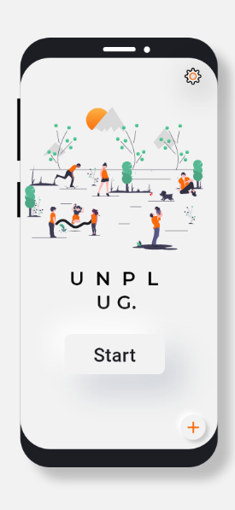focus on being minimalistic and target on the

main objective of reducing screen time.

* The title of the project is “Unplug” which

fits perfectly with our goal.

* The app includes feature like custom

alarm,statistics,one-click-detox.

* A signup page and feedback page has been

created in accordance with the app-design

to attract customers and improve app-

performance.

* User experiences have been set up to have

numerous feedbacks with the goal-objective

kept in mind.

­

# 

**UI & UX KEY FEATURES AND PRINCIPLES**

* **Meet the users’s needs.**

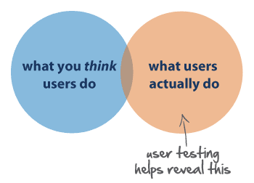

* **Know where you are in the design process.**

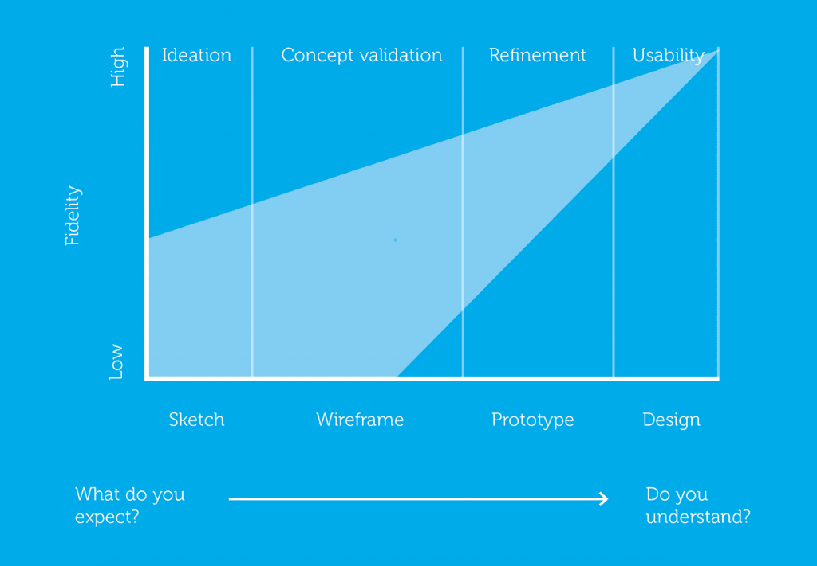

* **Less is more.**

The less-is-more approach emphasizes simplicity as opposed to clutter or over-decoration in design. Several celebrated designs have surfaced as a result of this UX design principle, including the iPhone and iPod. In 2007, Apple streamlined the phone’s keyboard in pursuit of the less-is-more philosophy and the iPhone was birthed. Apple’s website also follows the same design principle.

* **Use simple language**

Remember these five factors while designing app interfaces:-

* Audience and purpose of the design: question who your audience is, what information they have, what they need, and what they will want to achieve with your communication
* Structure: ask about the common structures for your communication, what structures your readers are familiar with, and what sequence will be easy to read
* Design layout: focus on the typography, layout, and information graphics
* Expression: consider the tone, verbs, sentence length, jargon, and choice of words your communication will adopt
* Evaluation: have someone review the text you finalize and conduct a usability test
* **Typography is powerful**

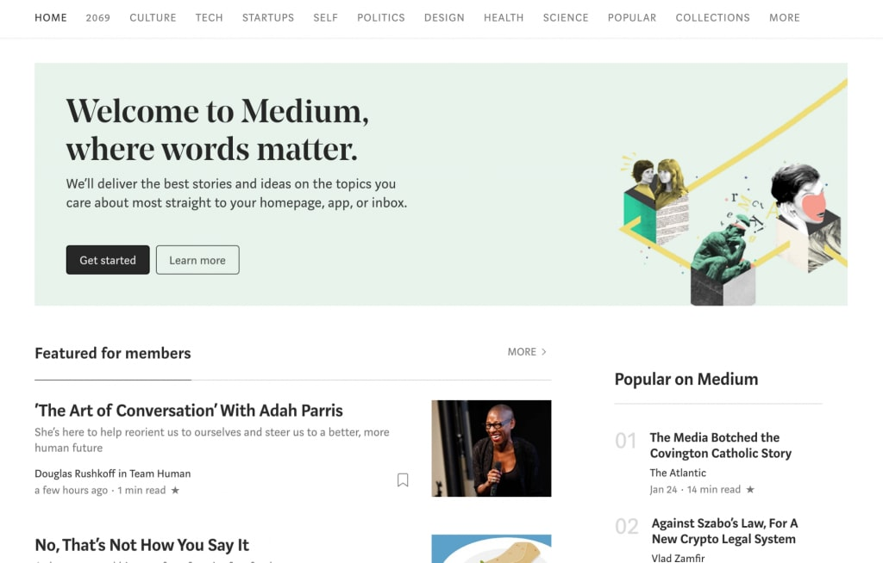

* **Feedback matters**

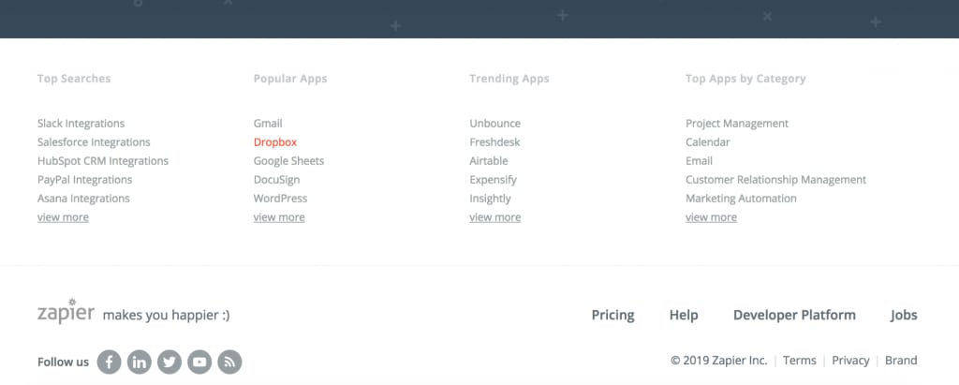

# 

# SIGN-UP PAGE AND FEEDBACK PAGE DESIGN

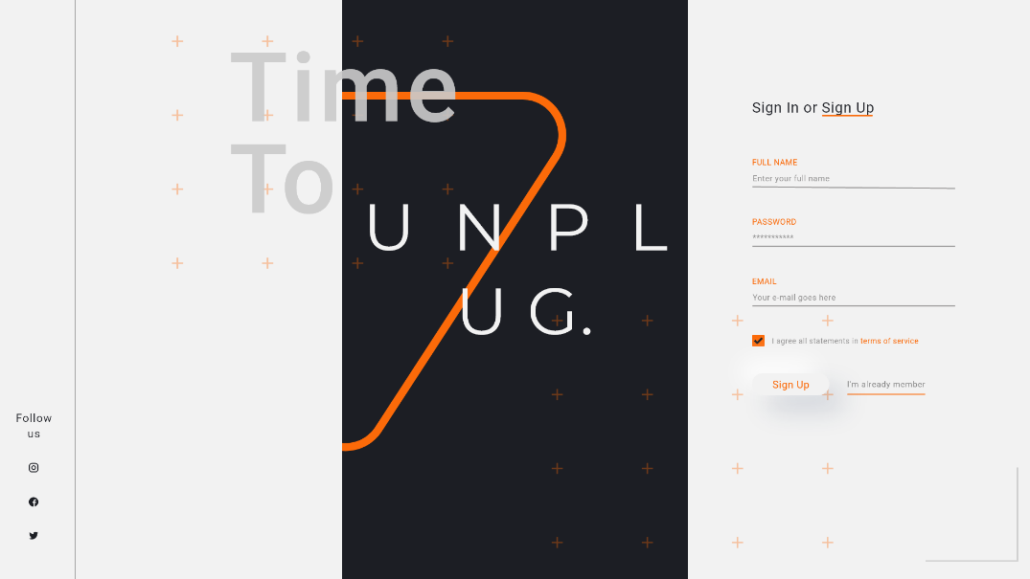

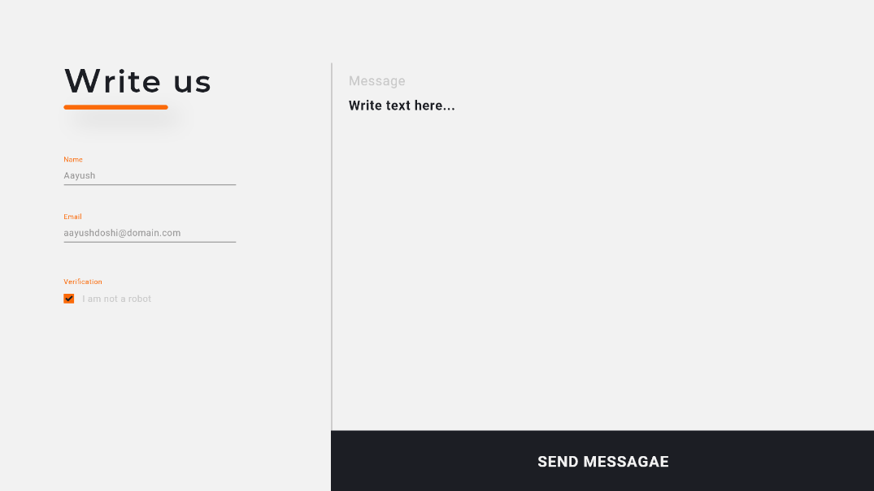

**Banner Design & Landing Page Design Features:**

* The Banner is design accustomed to the customer needs which contains the important tagline to “STAY LOCAL AND WORK GLOBAL”
* The Banner Design contains an idea of digitally marketing an online course of “Machine Learning” with mini tags explaining the features of the online course.
* Coming to the design tool, for the banner I have used Adobe XD and the logos are imported from different resources using png format.
* The landing page design is accustomed to an individual which contains the detailing of the person’s achievement in an attractive way
* The landing page is designed in both “Light-mode” and ‘’dark-mode’’. The main idealogy behind designing a portfolio page is to attract people to know more about the person’s work and this can improve for people seeking for jobs or company’s looking for employees**.**
* The landing page can also be used for a portfolio website.

# BANNER-DESIGN AND LANDING PAGE DESIGN

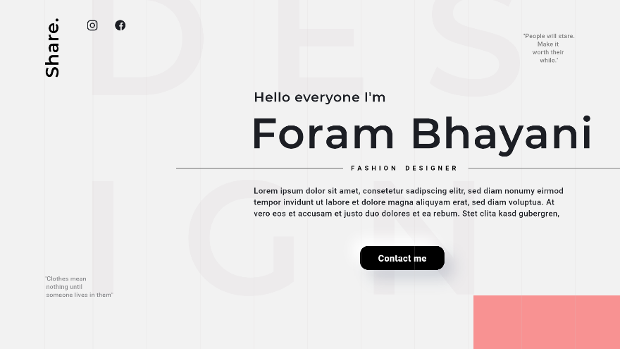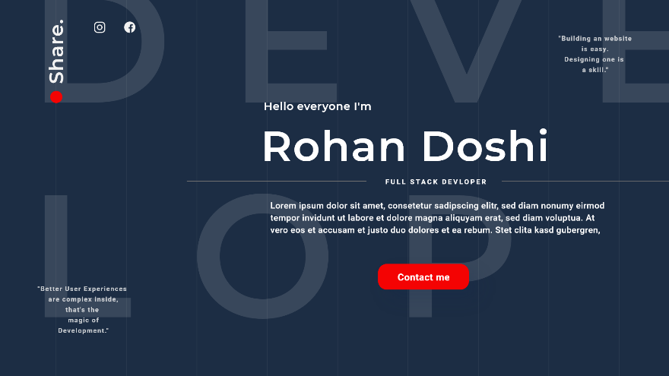**­­** APP-FEATURE DESIGNS

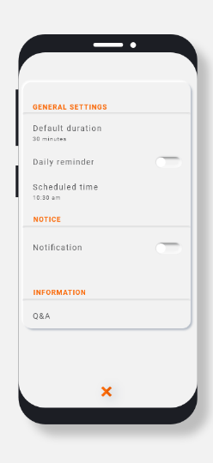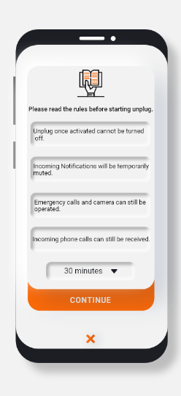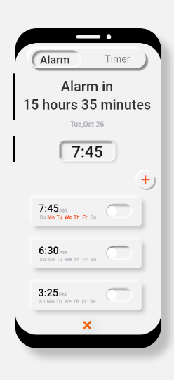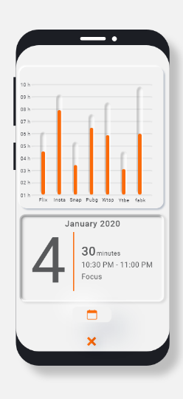

# CONCLUSION

The project took around 5-6 weeks to complete.The basics of understanding an UI & UX design and how to execute it. The goal was to resolve a complex issue of reducing “screen-time”, so that the customers could focus on much more important things and improve their work consistently.The project helped me understanding the key principles of design and how to adobt them in our daily project and to provide user with all the necessary features required for the goal.The add/banner design helped me understanding the view of an UI designer from a digital-market side and how its system work.For the portfolio design which would further help in CV and resume-building.

# FUTURE WORK

* Since I have learned some of the most basic things in UI & UX designing, I would like to gain much more expertise and experience in the field and learn how such designs solve real-world problems.
* Adobe xd has regularly been updating itself and so learning new skill-sets would be a constant work to improve myself.
* I would learn one step further by linking java-script codes and style sheets with the designs thus making a fully-fledged front end for a website or an app.
* Since user-testing field is evolving continously,I would learn various user stories and try to improve it by using in various projects.

**THANKYOU**